Steps:

1-)open url https://www.saucedemo.com/   
2-)at the UI page enter valid password (secret_sauce) only in the password field  
3-)click on login

Expected Result:

only to show error on the user name

Actual Result:

it showed an error in both

Priority:

Low

Severity:

low

Steps:

1-)open url https://www.saucedemo.com/  
2-)at the UI page enter valid username (standard_user) only in the username field  
3-)click on login

Expected Result:

only to show error on the password

Actual Result:

it showed an error in both

Priority:

low

Severity:

low

Steps:

1-)open url https://www.saucedemo.com/   
2-)at the UI page enter username locked_out_user in the username field  
3-) enter secret_sauce password in password field  
3-)click on login

Expected Result:

to successfully login

Actual Result:

it showed that the user has been locked

Priority:

Medium

Severity:

high

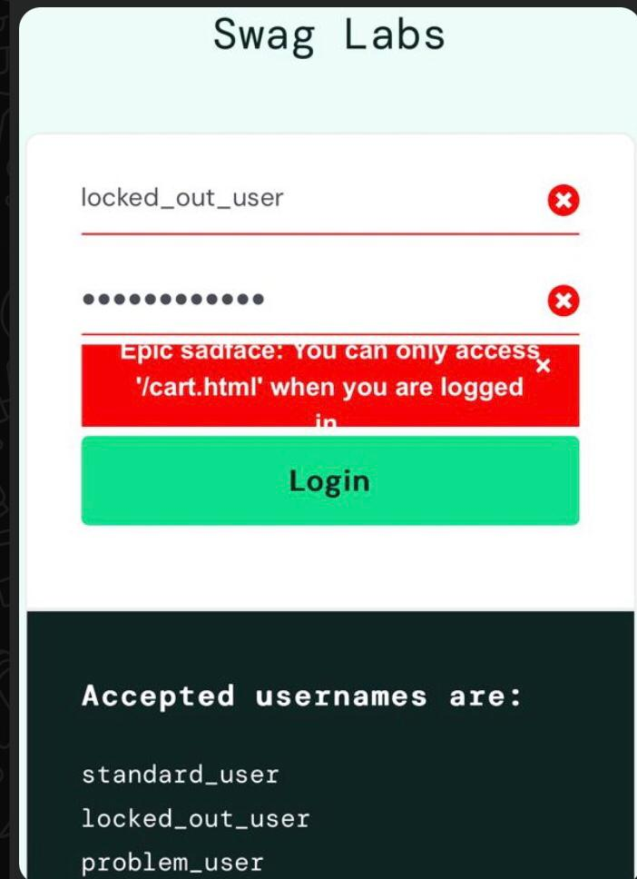

Steps:

1-)open url https://www.saucedemo.com/  
2-)at the ui page enter username locked_out_user in the username field  
3-) enter secret_sauce password in password field  
3-)click on login many times

Expected Result:

to show the same bug

Actual Result:

it showed that you can access (cart.html) only when you are logged in

Priority:

Low

Severity:

low

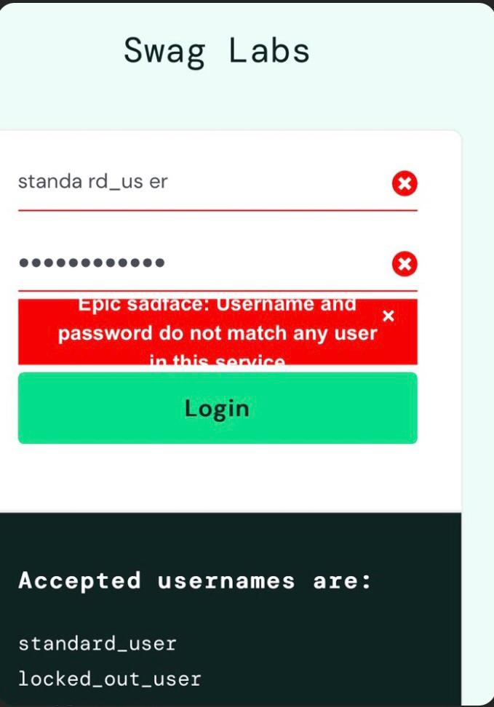

Steps:

1-)open url https://www.saucedemo.com/  
2-)at the ui page enter username standard_user with spaces in the username field  
3-) enter secret_sauce password in password field  
3-)click on login

Expected Result:

to show that the username only wrong

Actual Result:

it showed an error in both and username and password are required

Priority:

low

Severity:

low

Steps:

1-)open url https://www.saucedemo.com/   
2-)at the ui page keep user name empty in user name field   
3-) keep password empty in password field  
3-)click on login

Expected Result:

to show that the both are required

Actual Result:

it showed that the username only was the required

Priority:

Low

Severity:

low

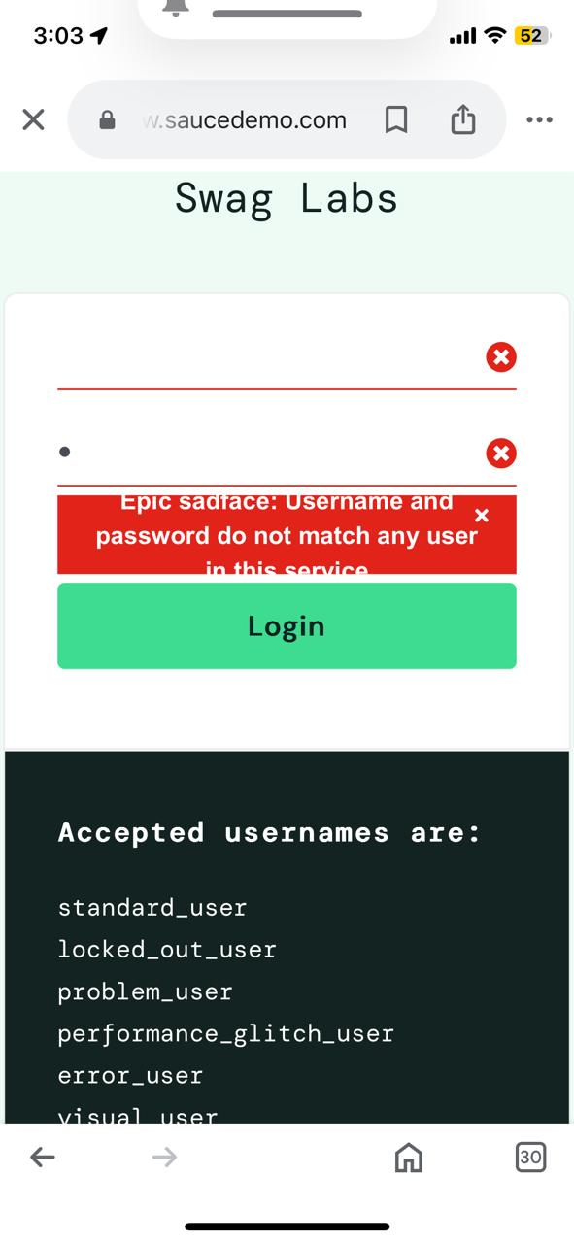

Steps:

1-)open url https://www.saucedemo.com/   
2-)at the ui page enter spaces in user name field   
3-) enter spaces in password field  
3-)click on login

Expected Result:

to show in password that there is no characters in password

Actual Result:

it showed characters while entering more than one space

Priority:

low

Severity:

low

Steps:

1-)open url https://www.saucedemo.com/   
2-)at the ui page enter spaces in user name field   
3-) keep the password field empty  
3-)click on login

Expected Result:

to show that both are required

Actual Result:

it showed that only passwrd was the required

Priority:

low

Severity:

high

Steps:

1-)open url https://www.saucedemo.com/   
2-)enter standard_user in user name field  
3-) enter secret_sauce in password field   
4-) click on login   
5-)at the main page there is no products photos appearing(on the mobile chrome)

Expected Result:

to show product photos

Actual Result:

it showed no photo

Priority:

medium

Severity:

high

Steps:

1-)open url https://www.saucedemo.com/   
2-)enter standard_user in user name field  
3-) enter secret_sauce in password field   
4-) click on login   
5-)at the main page there is products added automatically

Expected Result:

to be empty products added

Actual Result:

products added automatically

Priority:

medium

Severity:

high

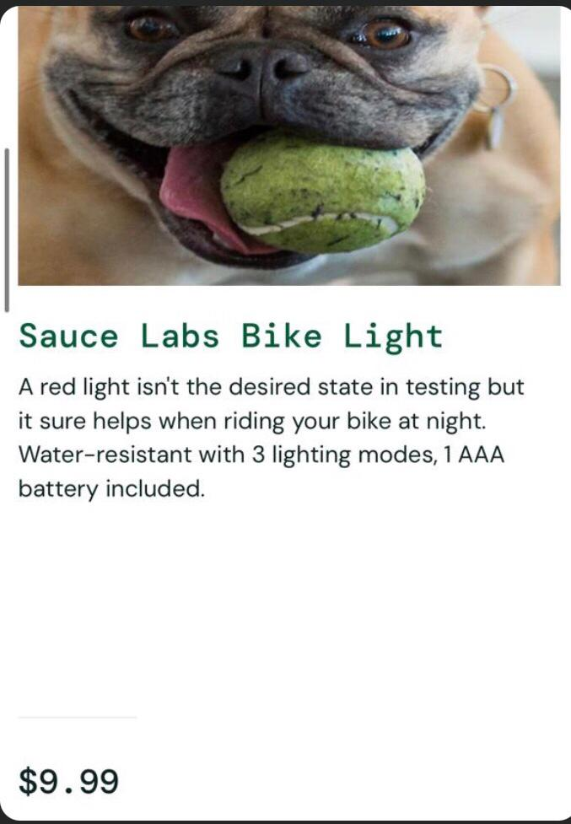

Steps:

1-)open url https://www.saucedemo.com/   
2-)enter problem_user in user name field  
3-) enter secret_sauce in password field   
4-) click on login   
5-)at the main page different price appeared in bike light than the standar_user

Expected Result:

to be the same price as in the other users

Actual Result:

different price appeared

Priority:

High

Severity:

high

Steps:

1-)open url https://www.saucedemo.com/  
2-)enter problem_user in user name field  
3-) enter secret_sauce in password field   
4-) click on login   
5-)at the main page make sort from (a to z)

Expected Result:

to show products sorted alphabetically

Actual Result:

an error message showen

Priority:

Medium

Severity:

low

Steps:

1-)open url https://www.saucedemo.com/  
2-)enter problem_user in user name field  
3-) enter secret_sauce in password field   
4-) click on login   
5-)at the main page make sort from (z to a)

Expected Result:

to show products sorted but not alphabetically

Actual Result:

an error message showen

Priority:

medium

Severity:

low

Steps:

1-)open url https://www.saucedemo.com/  
2-)enter problem_user in user name field  
3-) enter secret_sauce in password field   
4-) click on login   
5-)at the main page make sort for price from (high to low)

Expected Result:

to show price from (high to low)

Actual Result:

it showed the price from (low to high)

Priority:

medium

Severity:

low

Steps:

1-)open url https://www.saucedemo.com/   
2-)enter problem_user in user name field  
3-) enter secret_sauce in password field   
4-) click on login   
5-)at the main page make sort for price from (low to high)

Expected Result:

to show price from low to high

Actual Result:

it showed the price from high to low

Priority:

medium

Severity:

low

Steps:

1-)open url https://www.saucedemo.com/  
2-)enter standard_user in user name field  
3-) enter secret_sauce in password field   
4-) click on login   
5-)at the main page there is dog photos showed in the products on tablet

Expected Result:

to show product photos

Actual Result:

there is dog photos showed

Priority:

Low

Severity:

high

Steps:

1-)open url https://www.saucedemo.com/   
2-)enter problem_user in user name field  
3-) enter secret_sauce in password field   
4-) click on login   
5-)at the main page there is dog photo showed in the backpack product

Expected Result:

to show product photo

Actual Result:

there is dog photo showed

Priority:

low

Severity:

high

Steps:

1-)open url https://www.saucedemo.com/   
2-)enter problem_user in user name field  
3-) enter secret_sauce in password field   
4-) click on login   
5-)at the main page click on backpack product a backpack showed

Expected Result:

to show the back pack photo before and after clicking

Actual Result:

the back pack only showed after clicking

Priority:

low

Severity:

low

Steps:

1-)open url https://www.saucedemo.com/   
2-)enter performance_glitch_user in user name field  
3-) enter secret_sauce in password field   
4-) click on login   
5-)at the main page there is dog photos showed in the products on tablet

Expected Result:

to show product photos

Actual Result:

it showed dog photos instead of product photos

Priority:

low

Severity:

high

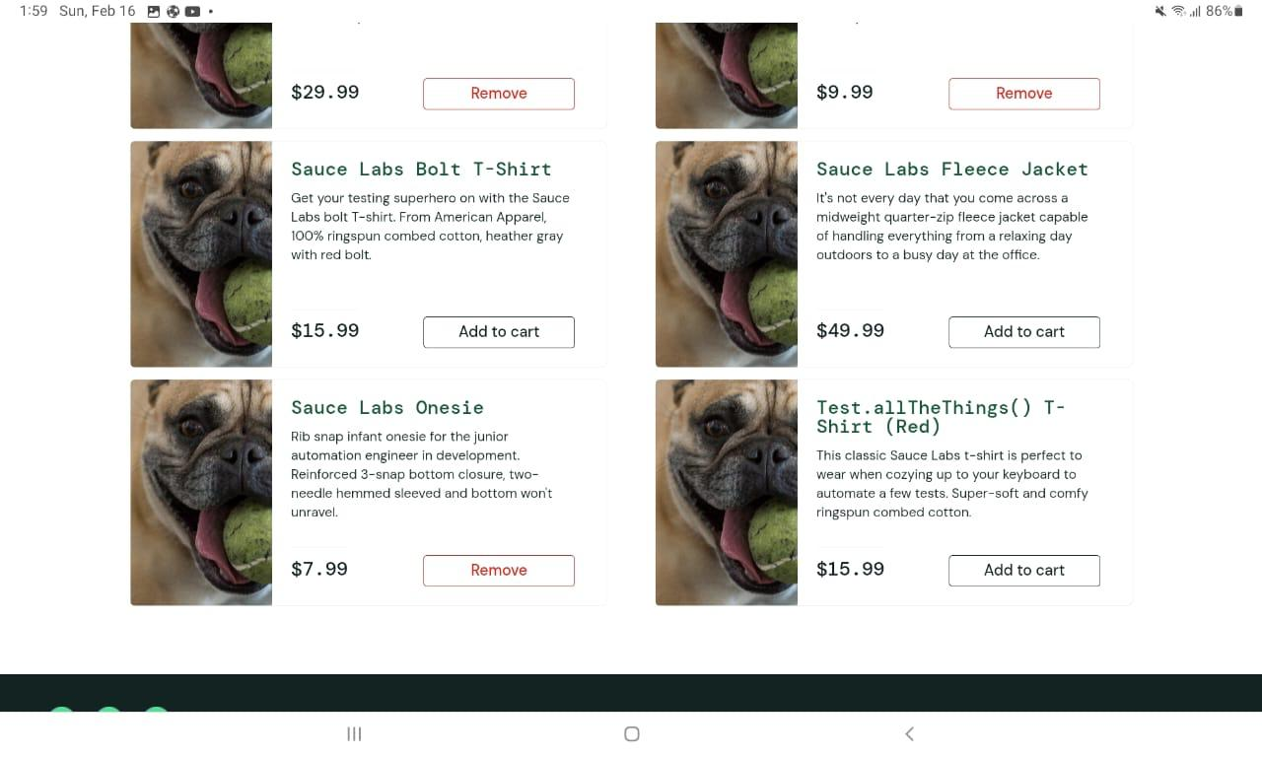

Steps:

1-)open url https://www.saucedemo.com/  
2-)enter performance_glitch_user in user name field  
3-) enter secret_sauce in password field   
4-) click on login   
5-)at the main page there is products added automatically

Expected Result:

to be empty products added

Actual Result:

there is products added automatically

Priority:

Medium

Severity:

high

Steps:

1-)open url https://www.saucedemo.com/   
2-)enter performance_glitch_user in user name field  
3-) enter secret_sauce in password field   
4-) click on login   
5-)at the main page the product bike light doesn’t able to be removed

Expected Result:

to remove this product

Actual Result:

the product bike light not removed

Priority:

high

Severity:

high

Steps:

1-)open url https://www.saucedemo.com/   
2-)enter error_user in user name field  
3-) enter secret_sauce in password field   
4-) click on login   
5-)at the main page there is products added automatically

Expected Result:

to be empty products added

Actual Result:

there is products added automatically

Priority:

medium

Severity:

high

Steps:

1-)open url https://www.saucedemo.com/   
2-)enter error_user in user name field  
3-) enter secret_sauce in password field   
4-) click on login   
5-)at the main page the products bike light and backpack and onesie products doesn’t able to be removed

Expected Result:

To be able remove them

Actual Result:

this products doesn’t able to be removed

Priority:

medium

Severity:

high

Steps:

1-)open url https://www.saucedemo.com/   
2-)enter visual_user in user name field  
3-) enter secret_sauce in password field   
4-) click on login   
5-)at the main page there is dog photo showed in the backpack pro

Expected Result:

to show product photo

Actual Result:

a dog photo was showed in instead of back pack photo

Priority:

medium

Severity:

high

Steps:

1-)open url https://www.saucedemo.com/   
2-)enter visual_user in user name field  
3-) enter secret_sauce in password field   
4-) click on login   
5-)at the main page the products tshirt and jacket products doesn’t able to be removed

Expected Result:

to remove them

Actual Result:

this products doesn’t able to be removed

Priority:

medium

Severity:

high

](https://youtu.be/RMkTAvhSezs) https://youtu.be/RMkTAvhSezs

Steps:

1-)open url https://www.saucedemo.com/   
2-)enter standard_user in user name field  
3-) enter secret_sauce in password field   
4-) click on login   
5-)at the main menu click on reset app

Expected Result:

to reset the app

Actual Result:

it doesn’t being able to reset the app

Priority:

medium

Severity:

high

](https://youtu.be/d1ydG9fpgVo) https://youtu.be/d1ydG9fpgVo

Steps:

1-)open url https://www.saucedemo.com/   
2-)enter standard_user in user name field  
3-) enter secret_sauce in password field   
4-) click on login   
5-)at the main menu click on all items

Expected Result:

to show all items

Actual Result:

it doesn’t being able to show all items

Priority:

medium

Severity:

high

](https://youtu.be/7NWYEhMEsj0) https://youtu.be/7NWYEhMEsj0

Steps:

1-)open url https://www.saucedemo.com/   
2-)enter problem_user in user name field  
3-) enter secret_sauce in password field   
4-) click on login   
5-)at the main menu click on reset app

Expected Result:

to reset the app

Actual Result:

it doesn’t being able to reset the app

Priority:

medium

Severity:

high

](https://youtu.be/P_Z-i4Da2DU) https://youtu.be/P_Z-i4Da2DU

Steps:

1-)open url https://www.saucedemo.com/   
2-)enter problem_user in user name field  
3-) enter secret_sauce in password field   
4-) click on login   
5-)at the main menu click on all items

Expected Result:

to show all items

Actual Result:

it doesn’t being able to show all items

Priority:

medium

Severity:

high

](https://youtu.be/CwMT-fhAUqg) https://youtu.be/CwMT-fhAUqg

Steps:

1-)open url https://www.saucedemo.com/   
2-)enter performance_glitch_user in user name field  
3-) enter secret_sauce in password field   
4-) click on login   
5-)at the main menu click on reset app

Expected Result:

to reset the app

Actual Result:

it doesn’t being able to reset the app

Priority:

medium

Severity:

high

](https://youtu.be/uFNj6CyY0ho) https://youtu.be/uFNj6CyY0ho

Steps:

1-)open url https://www.saucedemo.com/   
2-)enter performance_glitch_user in user name field  
3-) enter secret_sauce in password field   
4-) click on login   
5-)at the main menu click on all items

Expected Result:

to show all items

Actual Result:

it doesn’t being able to show all items

Priority:

medium

Severity:

high

](https://youtu.be/4ysSSbX0blg) https://youtu.be/4ysSSbX0blg

Steps:

1-)open url https://www.saucedemo.com/   
2-)enter error_user in user name field  
3-) enter secret_sauce in password field   
4-) click on login   
5-)at the main menu click on reset app

Expected Result:

to reset the app

Actual Result:

it doesn’t being able to reset the app

Priority:

medium

Severity:

high

](https://youtu.be/UrgMaTV5MUI) https://youtu.be/UrgMaTV5MUI

Steps:

1-)open url https://www.saucedemo.com/   
2-)enter error_user in user name field  
3-) enter secret_sauce in password field   
4-) click on login   
5-)at the main menu click on all items

Expected Result:

to show all items

Actual Result:

it doesn’t being able to show all items

Priority:

medium

Severity:

high

](https://youtu.be/Brjc7KWNpPs) https://youtu.be/Brjc7KWNpPs

Steps:

1-)open url https://www.saucedemo.com/   
2-)enter visual_user in user name field  
3-) enter secret_sauce in password field   
4-) click on login   
5-)at the main menu click on reset app

Expected Result:

to reset the app

Actual Result:

it doesn’t being able to reset the app

Priority:

medium

Severity:

high

](https://youtu.be/n_BzXW4R9mw) https://youtu.be/n_BzXW4R9mw

Steps:

1-)open url https://www.saucedemo.com/   
2-)enter visual_user in user name field  
3-) enter secret_sauce in password field   
4-) click on login   
5-)at the main menu click on all items

Expected Result:

to show all items

Actual Result:

it doesn’t being able to show all items

Priority:

medium

Severity:

high

Steps:

1-)open url https://www.saucedemo.com/   
2-)enter standard_user in user name field  
3-) enter secret_sauce in password field   
4-) click on login   
5-)at the main page click on the cart

Expected Result:

Not to show the check out option due to no selected products

Actual Result:

it showed the checkout option without selecting any product

Priority:

High

Severity:

high

Steps:

1-)open url https://www.saucedemo.com/   
2-)enter problem_user in user name field  
3-) enter secret_sauce in password field   
4-) click on login   
5-)at the main page click on the cart

Expected Result:

don’t show the check out option due to no selected products

Actual Result:

it showed the checkout option without selecting any product

Priority:

high

Severity:

high

Steps:

1-)open url https://www.saucedemo.com/   
2-)enter performance_gllitch_user in user name field  
3-) enter secret_sauce in password field   
4-) click on login   
5-)at the main page click on the cart

Expected Result:

don’t show the check out option due to no selected products

Actual Result:

it showed the checkout option without selecting any product

Priority:

high

Severity:

high

Steps:

1-)open url https://www.saucedemo.com/   
2-)enter error_user in user name field  
3-) enter secret_sauce in password field   
4-) click on login   
5-)at the main page click on the cart

Expected Result:

don’t show the check out option due to no selected products

Actual Result:

it showed the checkout option without selecting any product

Priority:

high

Severity:

high

Steps:

1-)open url https://www.saucedemo.com/   
2-)enter visual_user in user name field  
3-) enter secret_sauce in password field   
4-) click on login   
5-)at the main page click on the cart

Expected Result:

don’t show the check out option due to no selected products

Actual Result:

it showed the checkout option without selecting any product

Priority:

High

Severity:

high

Steps:

1-)open url https://www.saucedemo.com/   
2-)enter standard_user in user name field  
3-) enter secret_sauce in password field   
4-) click on login   
5-)at the main page click add products then click on the cart   
6-) click on check out   
7-) enter name and last name then enter invalid postal code field

Expected Result:

to be an error

Actual Result:

it accepted without an error

Priority:

medium

Severity:

high

Steps:

1-)open url https://www.saucedemo.com/   
2-)enter standard_user in user name field  
3-) enter secret_sauce in password field   
4-) click on login   
5-)at the main page click dont add products then click on the cart   
6-) click on check out   
7-) enter name and last name then enter valid postal code field

Expected Result:

to be an error

Actual Result:

it accepted without an error

Priority:

high

Severity:

high

Steps:

1-)open url https://www.saucedemo.com/   
2-)enter standard_user in user name field  
3-) enter secret_sauce in password field   
4-) click on login   
5-)at the main page click add products then click on the cart   
6-) click on check out   
7-) enter one letter in name and letters in last name then enter valid postal code field

Expected Result:

to be an error and not accept

Actual Result:

it accepted without an error

Priority:

medium

Severity:

high

Steps:

1-)open url https://www.saucedemo.com/   
2-)enter standard_user in user name field  
3-) enter secret_sauce in password field   
4-) click on login   
5-)at the main page click add products then click on the cart   
6-) click on check out   
7-) keep name and enter the last name then enter valid postal code field

Expected Result:

to show only an error in the user name

Actual Result:

it showed an error in all the fields

Priority:

medium

Severity:

high

Steps:

1-)open url https://www.saucedemo.com/   
2-)enter visual_user in user name field  
3-) enter secret_sauce in password field   
4-) click on login   
5-)at the main page add products then click on the cart   
6-) click on check out   
7-) enter first name and the postal code field

Expected Result:

not to be an error

Actual Result:

it showed an error due to the unable to enter digits in the last name

Priority:

medium

Severity:

high

Steps:

1-)open url https://www.saucedemo.com/   
2-)enter error_user in user name field  
3-) enter secret_sauce in password field   
4-) click on login   
5-)at the main page add products then click on the cart   
6-) click on check out   
7-) enter first name and the postal code field

Expected Result:

not to be an error

Actual Result:

it showed an error due to the unable to enter digits in the last name

Priority:

medium

Severity:

high

Steps:

1-)open url https://www.saucedemo.com/   
2-)enter performance_glitch_user in user name field  
3-) enter secret_sauce in password field   
4-) click on login   
5-)at the main page add products then click on the cart   
6-) click on check out   
7-) enter numbers in the first name and in postal code field and letters in lastname

Expected Result:

to be an error and not accept

Actual Result:

it accepted without an error

Priority:

medium

Severity:

high

Steps:

1-)open url https://www.saucedemo.com/   
2-)enter performance_glitch_user in user name field  
3-) enter secret_sauce in password field   
4-) click on login   
5-)at the main page add products then click on the cart   
6-) click on check out   
7-) enter first name and the lastname and letters in postal code field

Expected Result:

to be an error and not accept

Actual Result:

it accepted without an error

Priority:

medium

Severity:

high

Steps:

1-)open url https://www.saucedemo.com/   
2-)enter performance_glitch_user in user name field  
3-) enter secret_sauce in password field   
4-) click on login   
5-)at the main page add products then click on the cart   
6-) click on check out   
7-) enter first name and the lastname in numbers and put spaces in postal code field

Expected Result:

to be an error and not accept

Actual Result:

it accepted without an error

Priority:

Medium

Severity:

high

Steps:

1-)open url https://www.saucedemo.com/   
2-)enter performance_glitch_user in user name field  
3-) enter secret_sauce in password field   
4-) click on login   
5-)at the main page add products then click on the cart   
6-) click on check out   
7-) enter first name in special characters and the lastname in letters and enter numbers in postal code field

Expected Result:

to be an error and not accept

Actual Result:

it accepted without an error

Priority:

medium

Severity:

high

Steps:

1-)open url. https://www.saucedemo.com/   
2-)enter performance_glitch_user in user name field  
3-) enter secret_sauce in password field   
4-) click on login   
5-)at the main page add products then click on the cart   
6-) click on check out   
7-) enter first name and the lastname in numbers and enter numbers in postal code field

Expected Result:

to be an error and not accept

Actual Result:

it accepted without an error

Priority:

medium

Severity:

high

Steps:

1-)open url https://www.saucedemo.com/   
2-)enter performance_glitch_user in user name field  
3-) enter secret_sauce in password field   
4-) click on login   
5-)at the main page add products then click on the cart   
6-) click on check out   
7-) enter first name and the lastname in mixed numbers and letters and enter numbers in postal code field

Expected Result:

to be an error in first and last name only

Actual Result:

it shows an error in all the fields

Priority:

medium

Severity:

high

Steps:

1-)open url https://www.saucedemo.com/   
2-)enter performance_glitch_user in user name field  
3-) enter secret_sauce in password field   
4-) click on login   
5-)at the main page add products then click on the cart   
6-) click on check out   
7-) keep first name and the lastname and postal code fields empty

Expected Result:

to be an error in all fields

Actual Result:

it showed an error message that the first name only required

Priority:

medium

Severity:

high

Steps:

1-)open url https://www.saucedemo.com/   
2-)enter performance_glitch_user in user name field  
3-) enter secret_sauce in password field   
4-) click on login   
5-)at the main page add products then click on the cart   
6-) click on check out   
7-) enter letters with spaces in first name and the lastname and postal code fields

Expected Result:

to be an error in all fields

Actual Result:

it was accepted without an error

Priority:

Medium

Severity:

high

Steps:

1-)open url https://www.saucedemo.com/   
2-)enter performance_glitch_user in user name field  
3-) enter secret_sauce in password field   
4-) click on login   
5-)at the main page add products then click on the cart   
6-) click on check out   
7-) enter special characters in first name and the lastname and postal code fields

Expected Result:

to be an error in all fields

Actual Result:

it accepted without an error

Priority:

medium

Severity:

high

Steps:

1-)open url https://www.saucedemo.com/   
2-)enter performance_glitch_user in user name field  
3-) enter secret_sauce in password field   
4-) click on login   
5-)at the main page add products then click on the cart   
6-) click on check out   
7-) enter letters with spaces in first name and the lastname and numbers with spaces in postal code fields

Expected Result:

to be an error in all fields

Actual Result:

it accepted without an error

Priority:

medium

Severity:

high

Steps:

1-)open url https://www.saucedemo.com/   
2-)enter performance_glitch_user in user name field  
3-) enter secret_sauce in password field   
4-) click on login   
5-)at the main page add products then click on the cart   
6-) click on check out   
7-) enter spaces in first name and the lastname and in postal code fields

Expected Result:

to be an error in all fields

Actual Result:

it accepted without an error

Priority:

medium

Severity:

high